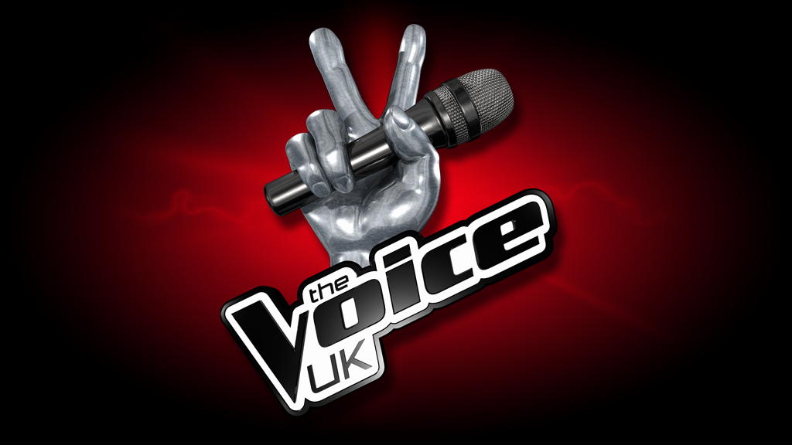
THE VOICE UK IS BACK!

Are you a singer with real talent and amazing
vocal ability?

Series 2 of the BBC’s hugely successful singing show, The Voice UK, is on the hunt for people who have a genuinely fantastic voice. Whether you’re a solo artist or duo, if you think you have what it takes to send those four chairs spinning, we want to hear from you!

To apply for the open auditions please complete the online application form on our official website:

http://www.bbcthevoiceuk.co.uk

To apply you must be 16 years of age or older on 31st August 2012 and have the right to live and work in
the UK.

Application forms need to be submitted by 28th July 2012

